9. Implement the non-parametric Locally Weighted Regression algorithm in order to fit data points. Select appropriate data set for your experiment and draw graphs.

***Locally Weighted Regression Algorithm***

**Regression:**

* Regression is a technique from statistics that is used to predict values of a desired target quantity when the target quantity is continuous.
* In regression, we seek to identify (or estimate) a continuous variable y associated with a given input vector x.
* y is called the dependent variable.
* x is called the independent variable.

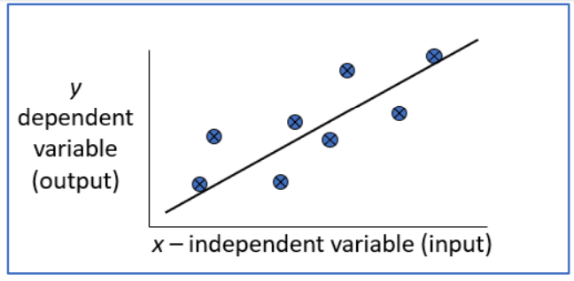

**Loess/Lowess Regression:**

Loess regression is a nonparametric technique that uses local weighted regression to fit a smooth curve through points in a scatter plot.

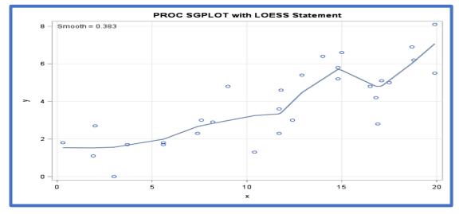

**Lowess Algorithm:**

* Locally weighted regression is a very powerful nonparametric model used in statistical learning.
* Given a dataset X, y, we attempt to find a model parameter β(x) that minimizes residual sum of weighted squared errors.
* The weights are given by a kernel function (k or w) which can be chosen arbitrarily

***Algorithm***

1. Read the Given data Sample to X and the curve (linear or non linear) to Y
2. Set the value for Smoothening parameter or Free parameter say τ
3. Set the bias /Point of interest set x0 which is a subset of X
4. Determine the weight matrix using :

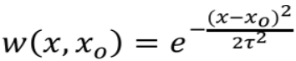

1. Determine the value of model term parameter β using :



1. Prediction = x0*β:

***Program***

import numpy as np

from bokeh.plotting import figure, show, output_notebook

from bokeh.layouts import gridplot

from bokeh.io import push_notebook

def local_regression(x0, X, Y, tau):# add bias term

x0 = np.r_[1, x0] # Add one to avoid the loss in information

X = np.c_[np.ones(len(X)), X]

# fit model: normal equations with kernel

xw = X.T * radial_kernel(x0, X, tau) # XTranspose * W

beta = np.linalg.pinv(xw @ X) @ xw @ Y #@ Matrix Multiplication or Dot Product

# predict value

return x0 @ beta # @ Matrix Multiplication or Dot Product for prediction

def radial_kernel(x0, X, tau):

return np.exp(np.sum((X - x0) ** 2, axis=1) / (-2 * tau * tau))

# Weight or Radial Kernal Bias Function

n = 1000

# generate dataset

X = np.linspace(-3, 3, num=n)

print("The Data Set ( 10 Samples) X :\n",X[1:10])

Y = np.log(np.abs(X ** 2 - 1) + .5)

print("The Fitting Curve Data Set (10 Samples) Y :\n",Y[1:10])

# jitter X

X += np.random.normal(scale=.1, size=n)

print("Normalised (10 Samples) X :\n",X[1:10])

domain = np.linspace(-3, 3, num=300)

print(" Xo Domain Space(10 Samples) :\n",domain[1:10])

def plot_lwr(tau):

# prediction through regression

prediction = [local_regression(x0, X, Y, tau) for x0 in domain]

plot = figure(plot_width=400, plot_height=400)

plot.title.text='tau=%g' % tau

plot.scatter(X, Y, alpha=.3)

plot.line(domain, prediction, line_width=2, color='red')

return plot

show(gridplot([

[plot_lwr(10.), plot_lwr(1.)],

[plot_lwr(0.1), plot_lwr(0.01)]]))

***Output***

